VZ SUPER GRAPHICS BY JOE LEON
8K SIDEWAYS VIDEO RAM — SUPER GRAPHICS ADAPTOR
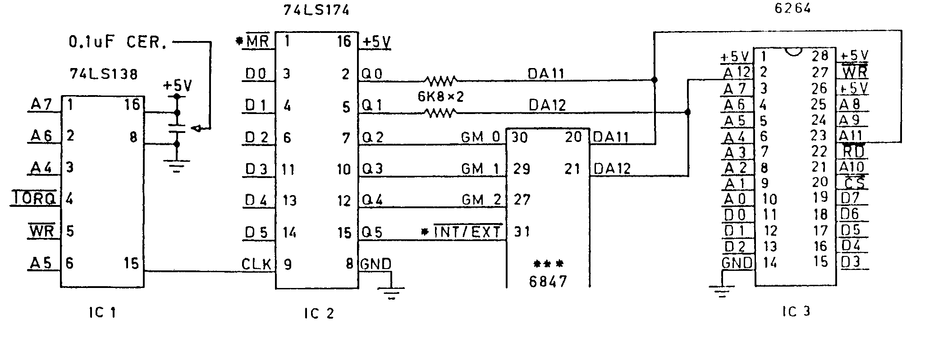
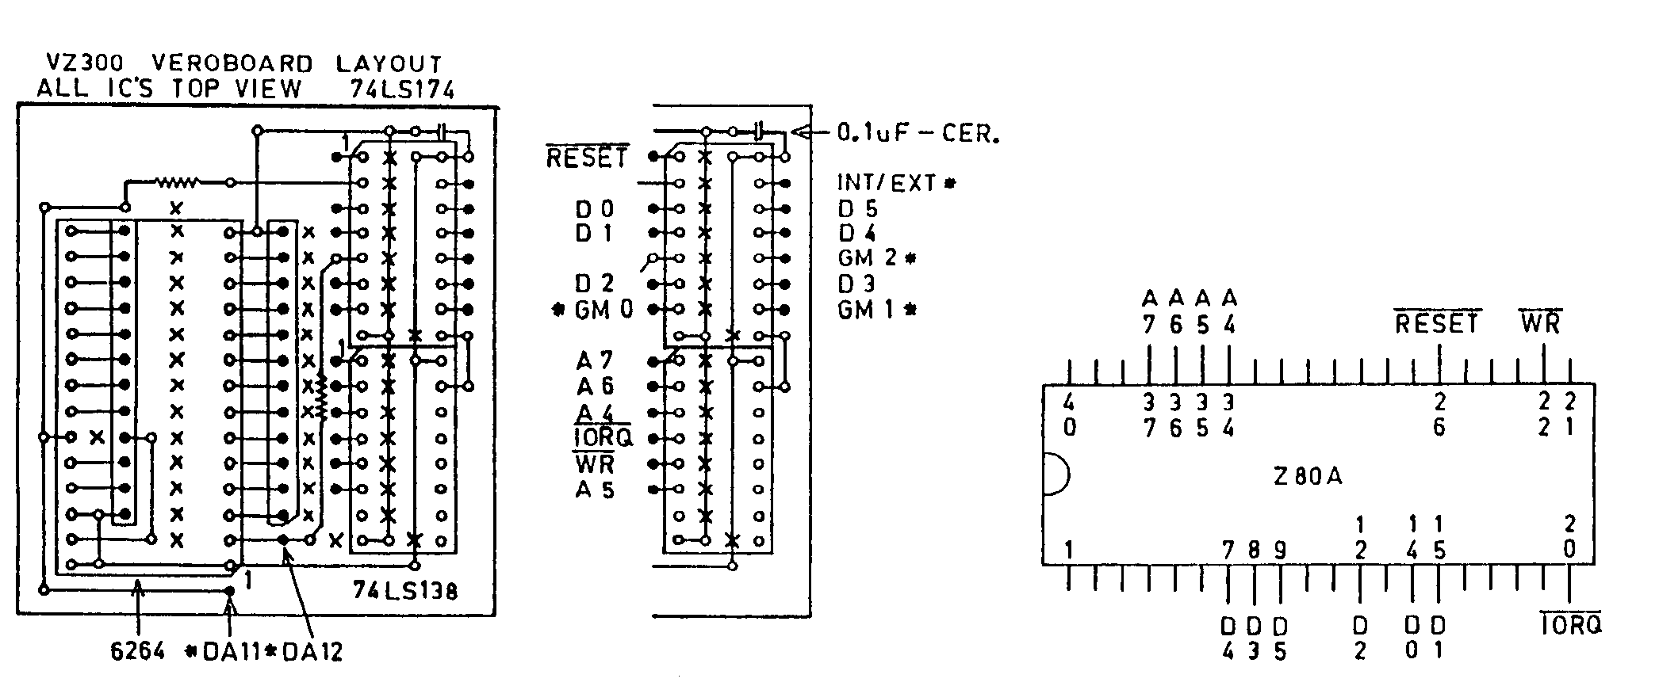
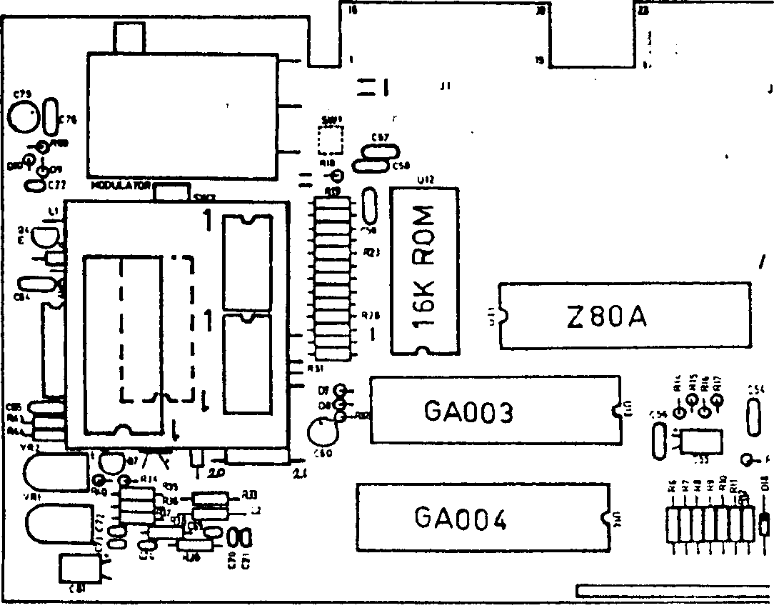
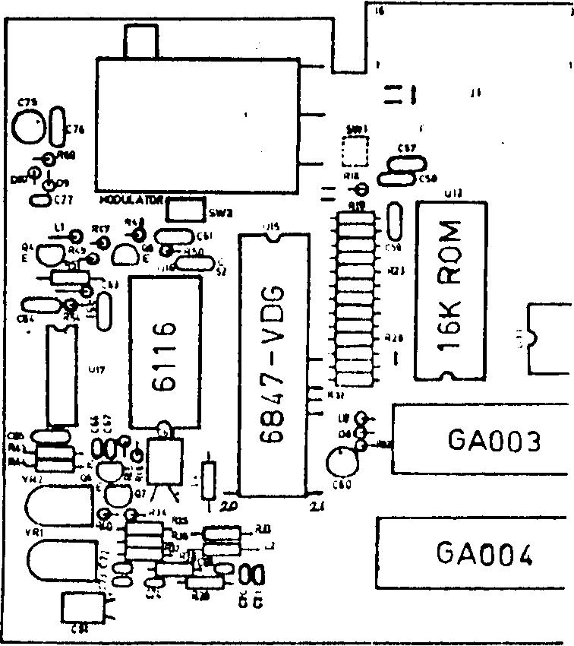
VZ SUPER GRAPHICS CONT . . . . 17
matthew sorell's ULTRA GRAPHICS ADAPTOR FOR VZ 200/300 INCREASED THE VZ PALTRY RESOLUTION TO 256 X 192 PIXELS MAXIMUM AND ADDED AN EXTRA 256 NEW CHARACTERS WHICH INCLUDED UPPER/LOWER CASE, greek, data 70 AND MATHEMATICAL AS WELL AS OTHER SYMBOLS.
besides matthew sorell, bob KITCH, chris hobrough AND MYSELF ARE SOME OF THE NAMES THAT SPRING TO MIND WHO HAD VARIOUS DEGREES OF SUCESS IN IMPROVING RESOLUTION ON THE VZ, BUT matthew HAD HIS DESIGN PUBLISHED FIRST AND I FOR ONE CONGRATULATE HIM, WELL DONE.
one DRAWBACK WITH THE DESIGN I FELT WAS IT REQUIRED HEAVY MODS TO THE VZ WHICH WOULD RULE OUT MANY WITH INSUFFICIENT EXPERIENCE FROM ATTEMPTING THE CONVERSION.
my ORIGINAL AND PRESENT DESIGN DOES NOT INCLUDE EXTRA CHARACTERS, ONLY THE FULL RESOLUTION THE 6847 VIDEO DISPLAY GENERATOR is capable off. I had TO change my design to make it COMPATIBLE WITH matthew's SO ANY SOFTWARE WRITTEN FOR THE HIGHER RESOLUTION WOULD WORK ON BOTH.
I CHOSE A MODULAR DESIGN APPROACH SO PERSONS WITH MUCH LESS EXPERIENCE SHOULD BE ABLE TO DO THE CONVERSION. only 3 IC'S ARE USED AND THEY ARE MOUNTED ON A PLUG IN MODULE. SO FAR I'VE CONVERTED ONE VZ 200 AND THREE VZ 200'S AND WAS FORTUNATE THEY ALL WORKED AFTER OVERCOMING SOME MINOR MISHAPS AND ONE VZ 300 WHICH HAS LOST ALL COLOUR WHICH I HAVE 'NT BEEN ABLE TO FIX.
the FOLLOWING CONSTRUCTION DETAILS AND VEROBOARD LAYOUT ARE FOR VZ 300 ONLY WHILE THE CIRCUIT DIAGRAM IS SAME FOR BOTH VZ 200/300. VZ 200 veroboard layout is completely different AND WILL B£ GIVEN IN NEXT ISSUE ALONG WITH INSTRUCTIONS FOR USING SUPER GRAPHICS AND SOME PROGRAMS. and NOW TO THE NITTY GRITTY.

CIRCUIT DIAGRAM :-
you'll NOTICE THE CIRCUIT IS VERY SIMILIAR TO MY S/WAYS RAM/ROM PROJECTS AND USES BANK SWITCHING TECHNIQUES, SOME OF WHICH ARE AUTOMATIC WHILE MANUAL SWITCHING CAN BE USED AS WELL AND IS WHERE ALL THE FUN COMES IN.
IC 1 - this IC DECODER IS USED AS A 16 BIT ADDRESS DECODER IN THE RANGE A32-A47 WHICH IS USED TO TRIGGER IC 2, A 6 BIT LATCH.
IC 2 - this 6 BIT LATCH (Q0 TO Q5) HAS TWO FUNCTIONS TO PERFORM.
1) - using BITS 0 & 1 BANK SWITCH IC 3, AN 8K VIDEO ram.
2) - USING BITS 2 - 4 SELECT GRAPHICS MODE 0 - 7 ON VDG 6847.
NOTE - bit 5 NOT REALLY NECESSARY, BUT IS INCLUDED FOR INTEREST.
IC 3 - the 6264, AN 8K RAM REPLACES THE 2K VIDEO RAM.
VDG - the 6847, A video display generator chip can address up TO 8K VIA IT'S 13 ADDRESS LINES, BUT IN CASE OF THE VZ ONLY ADDRESSES 2K. to GET THE MAXIMUM RESOLUTION OF 256 X 192, 6K OF video memory IS REQUIRED. as THERE'S NO SUCH THING AS A 6K RAM. AN 8K. RAM IS USED WHICH LEAVES US WITH A SPARE 2K FOR OTHER USES.
NOTE - IC 1, 2 & 3, two resistors and one decoupling capacitor ARE MOUNTED ON THE PLUG IN MODULE WHICH PLUGS INTO VACATED 2K video ram POSITION THEREBY SAVING OVER 30 CONNECTIONS.

VZ SUPER GRAPHICS CONT. . . . 18
PREPARING VZ 300 - first take VZ case apart and remove circuit board from CASE. next REMOVE RF SHIELD BY UNSOLDERING IT FROM PCB.
6116 - unsolder 2K VIDEO RAM OR CUT PINS ON ONE SIDE AND LEVER BACK AND FORTH TILL PINS BREAK ON OTHER SIDE. remove PIN STUBS AND INSPECT BOARD FOR DAMAGE. next soLDER A 24 PIN M/I SOCKET IN 6116'S PLACE.
6847 - there's NO NEED TO REMOVE THIS IC UNLESS YOU'RE CONFIDENT. using sMALL SIDECUTTERS CUT THE FOLLOWING PINS AS CLOSE TO THE PCB AS POSSIBLE AND BEND UP 90 DEG. cut pins 20, 21, 27, 29 & 30 oN 6847. pin 31 (INT/EXT) serves no USEFUL FUNCTION IN THIS DESIGN AS IT'S USED FOR EXTERNAL CHARACTER SET WHICH THIS DESIGN DOES NOT INCORPORATE.
Z80A - take tHE LID OF 40 PIN IDC DIL PLUG AND STICK LABEL ON TOP SIDE AND MARKING PINS WHICH WILL TAKE CONNECTIONS AND THEN SOLDER ON TOP OF Z80A MAKING SURE YOU HAVE NO SOLDER BRIDGES BETWEEN PINS.
PREPARING PLUG IN MODULE :-
VEROBOARD - the tRACKS RUN HORIZONTALLY, FROM LEFT TO RIGHT. open aND SOLID CIRCLES DENOTE USED HOLES ON VEROBOARD. vertical LINES DENOTE INSULATED LINK WIRES. horizontal LINES SIMPLY DENOTE USED TRACKS AND ARE SHOWN FOR CLARITY ONLY. the (X'S) DENOTE CUT TRACKS.
using aN 1/8" (3MM) DRILL BIT CUT TRACKS MARKED WITH AN (X) CHECKING AND DOUBLE CHECKING ALL ARE CORRECT AND HAVE 'NT MISSED ANY. next INSERT ALL LINK WIRES. please NOTE LINK WIRES UNDER 74LS174, PIN 8 & 74LS138 PIN 16 HAVE TWO WIRE LINK ENDS GOING INTO SAME HOLE. mount tWO RESISTORS AND CAPACITOR NEXT.
M/I adaptor stRIP - this IS A DOUBLE SIDED SINGLE ROW OF PINS WHICH CAN BE SNAPPED TO DESIRED LENGTH. one sIDE HAS THINNER PINS THAN OTHER SIDE. snap TWO LENGTHS OF 12 PINS EACH. insert tHE STRIPS IN THE 24 PIN RAM SOCKET WITH THINNER PINS AT BOTTOM.
next PUT VEROBOARD ON TOP OF PINS AND LOWER DOWN ON THEM. lift V/BOARD UP TILL IT JUST CLEARS COMPONENTS AND MARK HEIGTH ON PINS. remove PINS FROM SOCKET AND SOLDER THICK PINS TO V/BOARD TO MARKED HEIGTH AND CUT PINS FLUSH WITH TOP OF V/BOARD. the two stRIPS ON V/BOARD LAYOUT MARKED WITH SOLID CIRCLES IS WHERE THE STRIPS ARE SOLDERED TO.
using no sockets solder the 74LS174, 74LS138 & 6264 IC'S in next. using THE V/BOARD CUTAWAY AS A GUIDE SOLDER ALL 19 OFF BOARD LINK WIRES. using BIT OF THIN CARDBOARD LIKE FROM BACK OF WRITING PAD CUT A PIECE BIT LARGER THAN V/BOARD. cut two sLOTS FOR THE TWO STRIPS TO GO THROUGH AND INSERT C/BOARD UNDER BOARD WHICH IS USED TO INSULATE BOTTOM OF V/BOARD FROM COMPONENTS IN VZ.
plug IN MODULE IN VACANT 24 PIN SOCKET AND SOLDER THE 5/6 WIRES TO 6847 FIRST WHICH ARE DENOTED BY ASTERISKS. next oNE BY ONE CONNECT REMAINING WIRES TO Z80A. using VZ PCB LAYOUT AS A GUIDE TAKE WIRES AROUND BOTTOM, NOT ACROSS 16K rom IN CASE THE ROM HAS TO BE REPLACED AT A LATER STAGE. press tHE WIRES INTO SLOTS ON THE IDC DIL PLUG AND CUT OFF EXCESS. this aPPROACH SAVES A LOT OF SOLDERING AND IN CASE OF WIRING ERRORS ARE SIMPLY RECTIFIED.
TESTING - power UP THE VZ AND IF DISPLAY NORMAL TYPE IN OUT 32,9 AND PRESS RETURN. PRESSING ANY KEY WILL PRODUCE A NORMAL BEEB BUT NOTHING WILL BE HAPPENING ON THE SCREEN WHICH IS NORMAL. to gET BACK TO NORMAL RESET VZ OR TYPE IN CAREFULLY OUT 32,8 AND PRESS RETURN WHICH WILL RESTORE VZ TO NORMAL.
whenever yoU POWER UP OR RESET THE VZ TYPE IN OUT 32,8 AND PRESS RETURN. it's a gooD IDEA TO INCLUDE AN OUT 32,8 AT START IN ALL YOUR PROGRAMS. to TEST SUPER GRAPHICS AND BANK SWITCHING TRY THE FOLLOWING :-
VZ SUPER GRAPHICS CONT. . . . 19
RUN OR BRUN A HI-RES GAME THREE TIMES USING FOLLOWING SYNTAX :-
OUT32,24:MODE(1):RUN"YOURGAME" and press RETURN
OUT32,25:MODE(1):RUN"YOURGAME" and press RETURN
OUT32,26:MODE(1):RUN"YOURGAME" and press RETURN
the gaME WILL LOAD AND RUN IN TURN USING PAGE 0, TOP THIRD, PAGE 1, MIDDLE THIRD & PAGE 2, BOTTOM THIRD OF SCREEN. what wE ARE DOING IS SELECTING GRAPHICS MODE (6) and PAGE 0, PAGE 1 and PAGE 2. each page consists of 128 X 64 PIXELS AND WHEN WE ADD THEM TOGETHER WE GET 128 X 192 PIXELS. more DETAILED INSTRUCTIONS AND EXPLANATION IN NEXT ISSUE.

